Investigation into reuse of decommissioned STP infrastructure, improving treatment outcomes

Liz Millan, Chief Trainer, Simmonds and Bristow
Aleisha Myles, Coordinator Treatment Operations, Tablelands Regional Council

ABSTRACT

Atherton STP has a dual train SBR activated sludge treatment system. Potential for process optimisation was evaluated during Certificate IV Water Operations training onsite. Influent flow control was identified as a key factor which could contribute to process improvement. It was observed that the site had de-commissioned tanks from the old STP, which may be suitable for reinstatement and integration with the currently operating infrastructure. An investigation into the viability of this possibility, both physically and financially was undertaken. Additional factors affecting effluent quality were reviewed and some operational procedures were modified.

1.0 INTRODUCTION

The Atherton STP is a dual train SBR system, with alum dosing to enhance phosphorus removal.
The treatment plant had been experiencing somewhat erratic nitrogen removal, with the issue suspected to be poor de-nitrification. This was apparently giving rising sludge, interfering with effluent solids quality during the decant, plus comparatively high levels of nitrate in the final effluent. It was initially suspected that the low volume of incoming raw sewage during the night was limiting available soluble carbon (cBOD) and consequently hampering de-nitrification.

The plant averages around 2ML/day ADWF, with significant increases in wet season. Influent is predominantly domestic waste with a few small food based industries being the main trade effluent contributors. The SBR’s run on six x 4Hr cycles per day. Basin 1 has 2 hours of raw sewage feed (Fill) while Basin 2 has an hour each of settle then decant. Feed then swaps. Feed is plug flow during the Fill period (i.e. non-continuous), timing conditional on volumes received into the main pump station prior to the plant and wet well pump downs.

The mixed liquor is aerated intermittently during the Fill period. This in theory allows for periods of anoxic conditions, while sufficient soluble BOD is still present to drive de-nitrification (reduction of nitrate to nitrogen gas). Additional de-nitrification should occur to a lesser degree during the settle period.
When aeration coincides with the entries of the plugs of raw sewage into the basin, it was suspected to cause too much soluble BOD to be consumed aerobically. This limited the amount remaining to drive demand for nitrate as an alternative oxygen supply once aeration ceases.

The idea of using some sort of flow balancing tank, to try to control influent introduction rates and timing with respect to aeration pulses, was suggested. It was proposed it may help equalise feed volumes between the cycles also.
When we started speculating on the size of tank that might be needed to balance the flow (not forgetting the huge seasonal flow increase), we noticed a large round concrete tank up by the old inlet works. There was also a smaller green plastic tank with substantial associated pipework. What were these tanks? Could they be used?

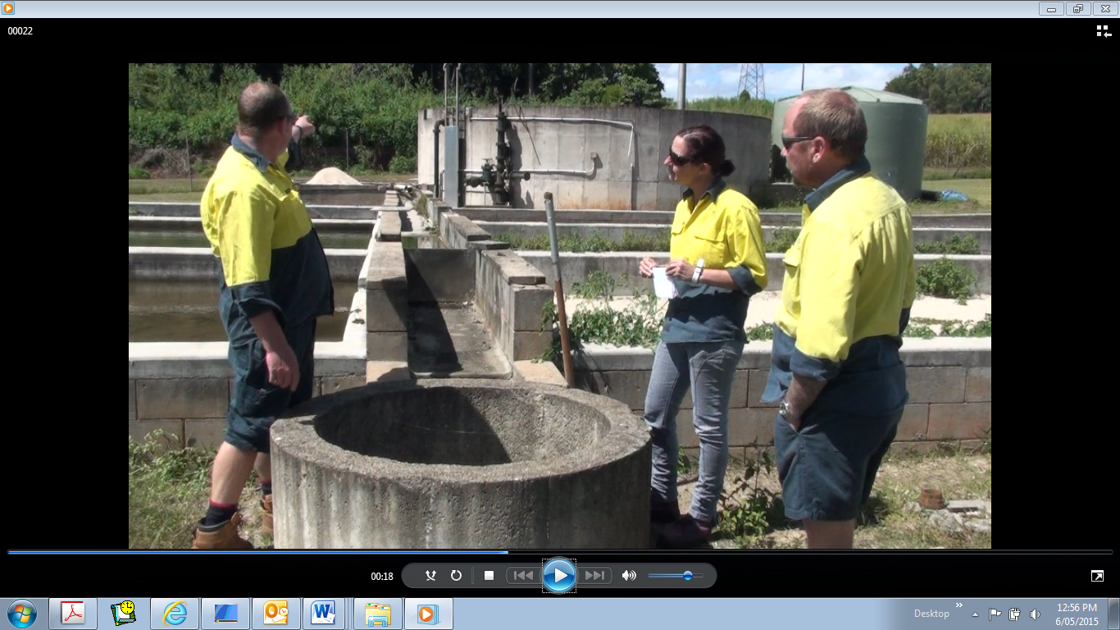

Figure 1: Atherton STP decommissioned tanks in background

2.0 DISCUSSION

It was decided that the investigation into “reusing” the decommissioned infrastructure would be a 7 step process.

1. Anecdotal evidence would be sought from long-time staff members, who were around when the decommissioning was happening, to see if there were any known structural, geotechnical or other issues which had triggered tank decommissioning.
2. Literature review – Hardcopy and electronic plans, investigations, consultant’s recommendation reports, upgrade option surveys etc. would be researched, to obtain infrastructure and utilities plans of the tank and pipework, plus also inform on any issues which might indicate against recommissioning of the tank
3. Calculate flows, volumes, capacity requirements to enable tank outputs to be quantified
4. Collate process data and identify any infrastructure issues e.g. missing or damaged pipework sections
5. Decide on a strategy for a comprehensive condition assessment to be completed
6. Identify mixer and outlet pump specifications
7. Concept design brief produced, to allow concept design development and costing

2.1 Steps 1 & 2 Anecdotes and drawings etc.
Initially it was thought that the concrete tank was part of the “old STP” (historically a trickle filter / clarifier), perhaps a primary sedimentation tank. The green plastic tank was thought to have been installed when it was mooted that the plant take sewage from a remote adjoining community. It was thought the green tank had never been put into use.
An informal survey was conducted amongst longstanding staff members. We were fortunate to have a visit to site by Mr Errol Taske – Co-ordinator of Water & Sewer Reticulation.

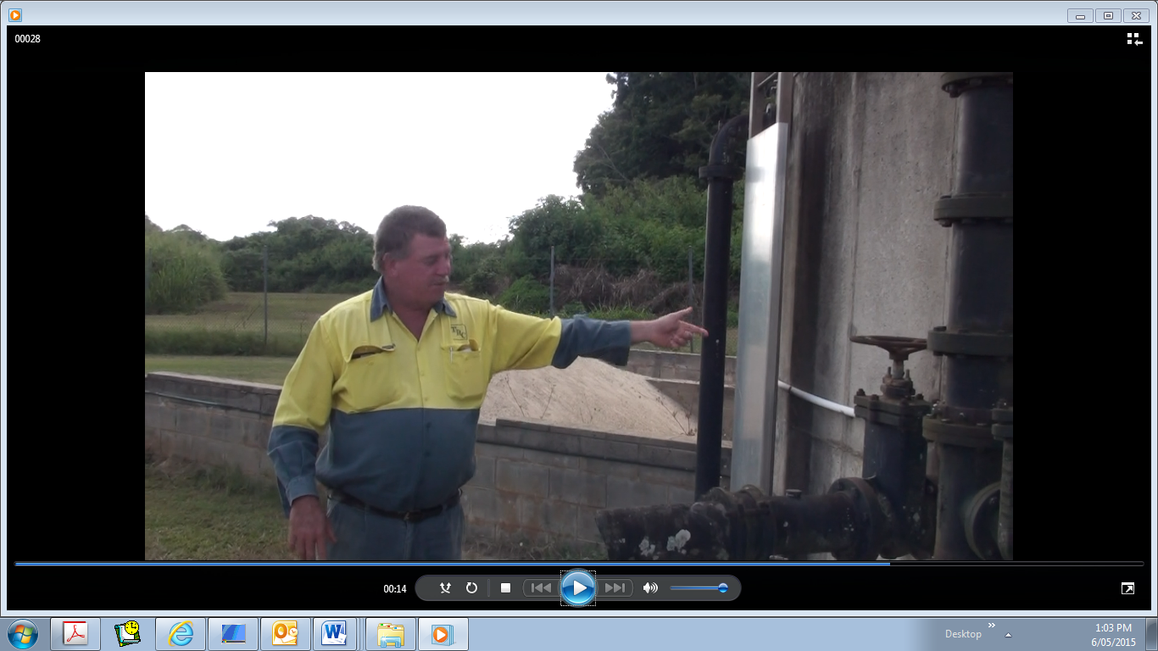

Figure 2: Errol describing concrete tank historical function

He was able to correct our mistaken assumption and identified that the concrete tank was historically designed to be a digester of humus sludge from the trickle filter clarifier. It did have a supernatant return line to the head of the plant. There were no known structural issues that Errol was aware of, so no faults in tank integrity or water tightness. During this site inspection it was identified that the green tank was actually in use, receiving a very low volume of flow from the Tolga community. It was clear that minimal operator control was being exercised over this input of ammonia and other nutrients.
Quite a difficult time was had trying to locate drawings and plans of the historical and current treatment plant structures!!

2.2 Step 3 Flow trending and volume calculations

Some flow trends were sourced from SCADA and used to estimate typical weekday flow distribution, to attempt to get a ballpark estimate of desired flow balance tank capacity.
Analysis of the raw sewage (Fill or food volume) data for a typical weekday in dry weather (28/04/15) showed an interesting distribution across the 24 hours and between the two SBR units. The flow of raw sewage (food) was fairly even in volume from each 2 hour Fill period, until the night-time hours of 1130pm – 530am.

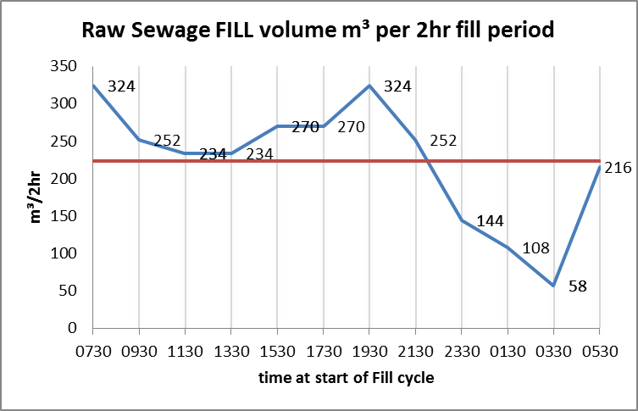

Figure 3: Volume of Raw Sewage received in each 2Hr Fill interval

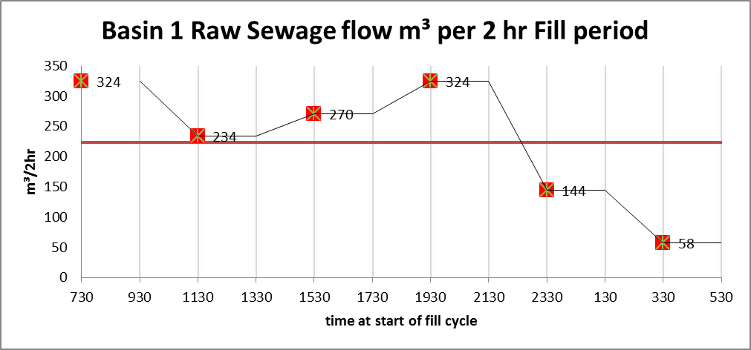

Figure 4: Basin 1: Volume of Raw Sewage received in each 2Hr Fill interval

Basin 1 Fill volumes and hence bug food supply is very changeable from cycle to cycle, with both highest volumes observed (7.30 am & pm peak flows) and lowest volumes at 1130pm and 330am.
In contrast flow and food are significantly more consistent for SBR Basin 2, with only one low volume cycle in every 6.

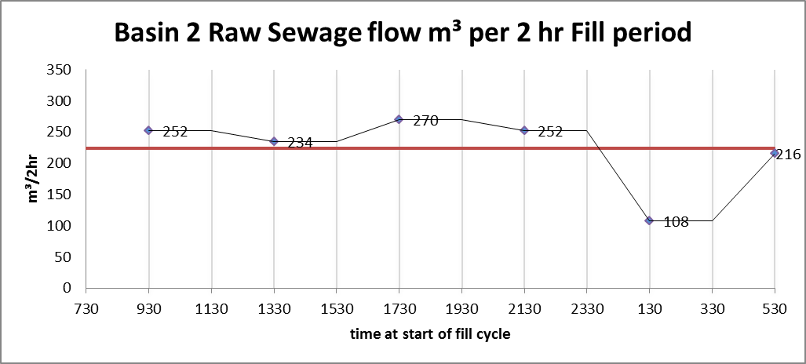

Figure 5: Basin 2: Volume of Raw Sewage received in each 2Hr Fill interval

SBR Basin 2, has historically shown lower MLSS and improved settleability and effluent clarity when compared to SBR Basin 1.

2.3 An unfortunate truth

It was estimated that the flow balance tank would need to accumulate around 370m³ of raw sewage during the 18 hours of 530am – 1130pm.This would then be fed back in to supplement the lower nighttime volume of influent received. The aim would be a fairly constant volume of roughly 224m³ feed per 2 hour fill cycle. To accommodate wet weather flow, ideally the flow balance tank (or an additional side stream flow tank) should hold 10X this volume, namely 3700m³. Whatever tank is selected must allow for mixing and appropriate withdrawal flow at either volume extreme.

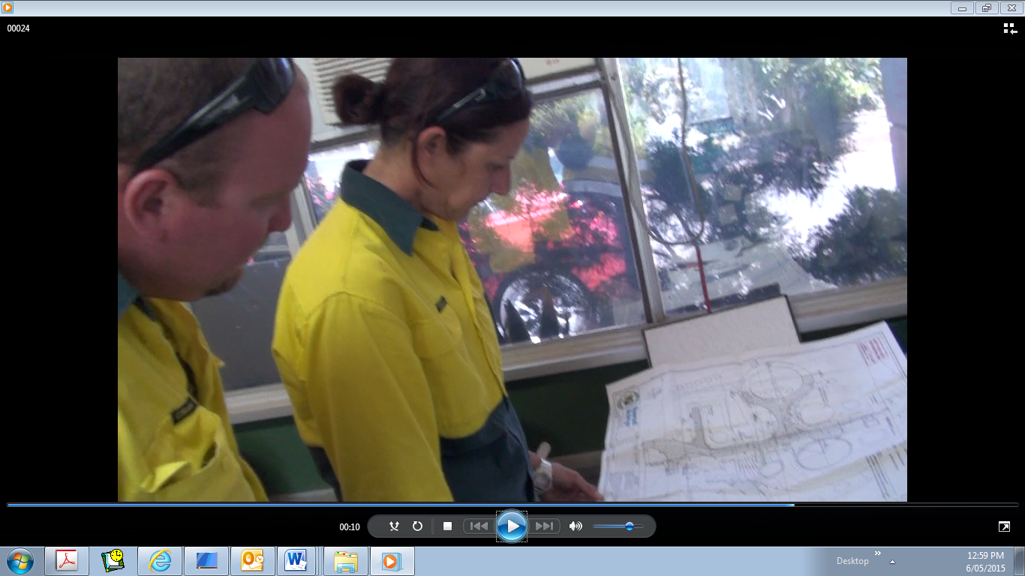

Figure 6: The plans found…and then the bad news

These volume requirements put a spanner in the works when plan dimensions for the concrete tank became available (we should have paced it out and done a rough calculation earlier!). Unfortunately it seemed likely maximum practical volume would be just under 236m³, well short even of the minimal 370m³ estimate.

2.4 Step 4 Process data review

Along with the historical document investigation and flow & volume calculations, a more in depth review of the monitoring data was undertaken. It was identified that TON (Total oxidised nitrogen) was somewhat pointlessly monitored in the raw sewage, yet not tested in the final effluent, where it would offer valuable process control information. This situation is being rectified.

Review of results showed issues with nitrogen compliance, but with a range of causes, from the high nitrate originally pinpointed as the problem, through to high ammonia with & without accompanying high nitrate.

There is limited control over the impacts of a number of influent and process streams, which carry high concentrations of ammonia. When the gravity deck is running to dewater the WAS, this filtrate water returns to the inlet structure. Septage loads are received into the plant from local cartage companies, with a corresponding impact on influent ammonia load.

The system is severely alkalinity limited, so deficient that frequently no residual alkalinity is detected in the final effluent. This situation is amplified by the practice of dosing of alum into the influent, for chemical phosphorus control. It is clear from the DO trends that generally the blowers are able to supply sufficient air to reach the DO set points, so lack of oxygen should not inhibit nitrification.

The observations above suggest that either sludge age is verging on too low, and/or alkalinity limitations are inhibiting nitrifying bacterial reproduction. It is also likely ammonia nitrogen load fluctuates considerably from external and operational sources.

Night time aeration pattern is insufficiently regulated to allow enough of a truly anoxic period, and this along with the drop in soluble BOD, leads to high levels of oxidised nitrogen (mainly nitrate) in the final effluent.

It was also identified WAS control is erratic, with sometimes counterproductive changes made and lack of action on irregular pump rates. Further investigation of the WAS pumps showed it was actually faulty frog flaps allowing WAS from Basin 2 to be diverted into Basin 1 instead of to waste at the gravity deck, and vice versa. This diverted flow did not register on the WAS flow meter.

2.5 The “new” Step 5 Where to from here?

The surprise was that these early stages of the investigation showed that a lot more operational monitoring and optimisation would be necessary, before the true need for flow balancing would be able to be accurately identified.

It was identified upon review of the current operation and monitoring regime that the operators had considerable access to alter the aeration sequencing and On/Off durations during each basin’s fill cycles. The two basins can be programmed separately, also each of the 6 cycles are able to have different sequencing from each other if necessary. Some attempts have been made to match aeration patterns with expected DO demands, but these have been set quite arbitrarily.

Considerably more comparison and correlation of flows and “plug flow patterns” between the cycles and intervals within the cycle, and more nitrogen testing at various intervals during the Fill periods is needed. Monitoring of dissolved oxygen trends in more detail will also help identify process limiting factors, which it appears may be quite variable from cycle to cycle.

Investigation of suitable sources of supplementary alkalinity to improve the nitrification process is also planned.

3.0 CONCLUSION

It was clear that what was initially described as the cause of the effluent quality issues (de-nitrification process failings) was often not the actual cause of effluent high total nitrogen. The lesson is to review available monitoring data to identify the “real” effluent quality issue(s), rather than rely on what you are told is the problem.

In hindsight we should perhaps have modified the order of the investigation steps, with calculation of likely flow balance volume requirements first, before infrastructure investigation commenced.

Some valuable information was gained from the investigation process however, with operational team gaining considerably from the review process. A pathway forward for additional monitoring trials, with a view to optimising aeration interval timings for each cycle (and basin) should help bring the nutrient removal process under enhanced control with improved effluent quality as the outcome.

4.0 ACKNOWLEDGEMENTS
Thanks to the Atherton STP operators and Errol Taske.

