MEASURING THE POWER OF DISINFECTION: WHAT YOU NEED TO KNOW

Mario Ruckli, Graduate Engineer, Simmonds & Bristow

ABSTRACT

In the context of potable and pool water, effective disinfection is perhaps the most important thought, and the effects of poor disinfection can be felt by an entire community. In fact, water disinfection is a concept that dates back to 2,000 BC (granted, our technology has improved to this day). As such, the operator should have a keen understanding of how to measure the power of disinfection in water. Two options for assessing disinfection power include monitoring of free chlorine, and ORP (oxidation reduction potential). The two measures are different, but how do they differ and what do the numbers actually tell us?

This paper seeks to give operators food for thought and some healthy curiosity when they next find themselves measuring free chlorine or ORP. From the basics of how the humble chlorine ion reacts in water, to the reason why a millivolt is a relevant unit of measurement for water quality, the discussion in this paper is a comparison of the two monitoring methods.

KEY WORDS: disinfection, chorine, ORP, oxidation reduction potential, potable water, pools.

1.0 INTRODUCTION

Operators bear a great deal of responsibility in ensuring that water for public use is safe. To ensure safety, a range of operational targets need to be met. Free available chlorine and ORP targets are commonly set in water treatment plants and public pools, to measure the ability of the water to be disinfected.

In this paper, we will look at what the two measurements actually mean, and what we should be considering when assessing disinfection power.

So, what is free available chlorine?

Free available chlorine (FAC, also known as free residual chlorine) is the portion of chlorine that remains available for disinfection, after the chlorine reacts with compounds in the water. A minimum free available chlorine concentration is required in potable and pool systems as it confirms that disinfection occurred, and there is remaining chlorine to prevent recontamination.

Chlorine can react with organic and inorganic compounds, including bacteria, metals, and ammonia. Chlorine which reacts with ammonia (to form chloramines) still possesses the ability to disinfect water, but to a weaker extent.

FAC is comprised of hypochlorite ions (OCl-) and hypochlorous acid (HOCl), which are formed when chlorine is added to water. The mechanism of chlorine disinfection is oxidation, a process of electron transfer that can destroy biological organisms. The cell walls of bacteria hold a negative charge, which causes hypochlorite ions to be repelled from the organisms, so disinfection occurs best with hypochlorous acid, since it does not have the negative charge that hypochlorite ions have.

The balance of hypochlorite ions and hypochlorous acid in chlorinated water depends on the pH of the water, with hypochlorous acid favouring lower pH (6.0 – 7.6), and hypochlorite ions favouring higher pH (7.6 – 10). A pH below 7.6 is ideal for disinfection, with pH in the low-7 range typically seen at treatment plants.

Total available chlorine
Free available chlorine
Hypochlorite ion, OCl-
Hypochlorous acid, HOCl
Combined chlorine
Organic and non-organic compounds (e.g. metals)
Chloramines (ammonia-based compounds)

Figure 1: Components of chlorine in water

What is ORP?

ORP stands for oxidation-reduction potential, and is also known as redox potential. ORP is commonly monitored for swimming pools and potable water supplies. Oxidation was originally defined as the gain of oxygen (hence the term), however a more general definition has been produced based on electron loss and gain, with oxidation being a loss of electrons and reduction a gain in electrons. ORP is measured in millivolts and represents the tendency of a system to either donate or accept an electron.

Since chlorine disinfection is an oxidation process, ORP can inform us as to whether the conditions within the water are favourable to disinfection. A positive ORP value indicates an oxidative environment, which is desired for water treatment, whereas a negative ORP value suggests that there is a greater potential for reduction, which is less desirable.

For chlorine disinfection, hypochlorous acid is an oxidising agent. Hypochlorous acid can react with reducing agents or other less powerful oxidants, which can include hypochlorite ions, chloramines, cyanuric acid, organic matter, and micro-organisms.

2.0 DISCUSSION

2.1 Measuring Free Available Chlorine
Free available chlorine is typically measured using the DPD method. The DPD method is quick and simple, making use of DPD (N,N Diethyl-1,4 Phenylenediamine sulphate) reagents that react with chlorine to produce a magenta dye that is measured with a colorimeter.

What does a FAC measurement tell us?

Most importantly, a presence of FAC tells us that breakpoint chlorination has been achieved. Breakpoint chlorination is a very important idea for water treatment, and achieving breakpoint means that the chlorine demand has been fully satisfied. Any additional chlorine added to the water remains as FAC. A reasonable FAC concentration (typically 0.2 to 0.5 mg/L for potable water) also tells us that the water will remain disinfected in reticulation.
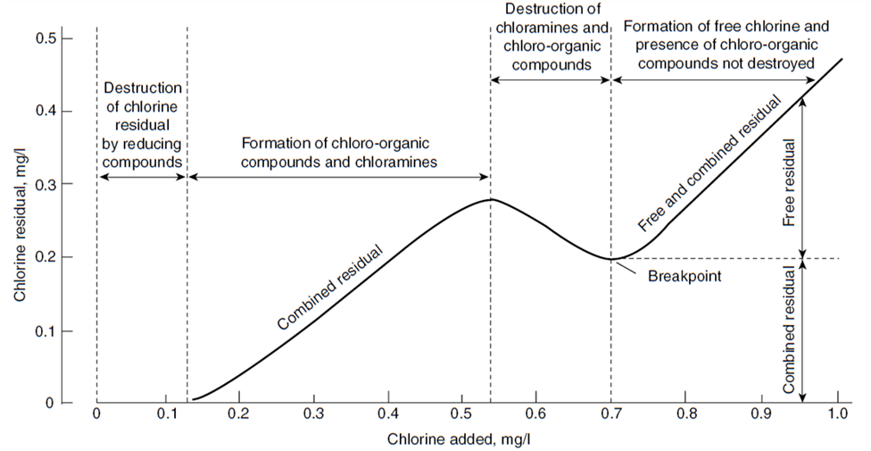
Figure 2: Breakpoint chlorination curve (Samer, 2015)

What can a FAC measurement not tell us?

If a free chlorine residual test returns a result of zero, it is difficult to determine how much additional chlorine must be added to achieve breakpoint chlorination. Chlorine can react with a variety of materials, including organic compounds and ammonia (which forms chlroamines). If ammonia is present, high chlorine to ammonia ratios are necessary for destroying chloramines to produce free available chlorine (roughly 7:1 Cl:N; chloramines will fully oxidise to chloride and nitrogen). “Burning out” the ammonia present can be a reason to carry out superchlorination in swimming pools, and can drive very high chlorine dose rates in waters with naturally high ammonia concentrations.

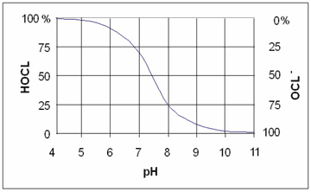
Measuring FAC does not tell us how much hypochlorous acid we have, although we can estimate that if we also know the pH of the sample, which allows us to judge the disinfection power of the chlorine.

Figure 3: HOCl and OCl- speciation for a typical pH range (Hach, 2017)

Ideally, FAC measurement is followed up with total available chlorine (TAC) measurement (by the simple addition of DPD-3 to the sample), in order to determine how much combined chlorine is present in the sample. In fact, the Queensland Health Swimming and Spa Pool Water Quality and Operational Guidelines 2004 suggest that combined chlorine should only form a minor part of the total chlorine – not only are chloramines far weaker disinfectants than free chlorine compounds, they are also the primary cause of taste and odour problems. Some treatment facilities do successfully apply chloramination as a disinfection strategy; however this is generally a special case as the system needs to be tightly controlled.

The presence of substantial amounts of both chloramines and free chlorine can suggest that the system is just at breakpoint chlorination.
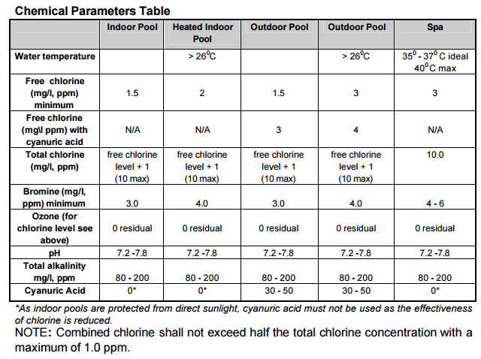
Figure 4: Recommended chemical parameters table for swimming pools. Note the requirement for combined chlorine to be low, even though it still has disinfection power (Qld Health, 2004)

2.2 Measuring ORP
ORP is typically measured with an ORP probe that contains an ORP electrode and a reference electrode, similar to how pH is measured.

Physically, ORP is measured by comparing the output of an ORP electrode (which can either gain or accept electrons, altering its output), and a neutral “reference” electrode (which creates a constant output for comparison). The ORP measurement can be dependent upon the pH and temperature of the sample, so care should be taken to check whether your meter will automatically account for these or not.

What can an ORP measurement tell us?

The primary benefit of ORP measurement is that it can be an indicator of disinfection rates, with higher ORP values correlating with faster kill times of micro-organisms. High ORP values suggest that sufficient hypochlorous acid is available in the water.

ORP monitoring is more common overseas, and suggested redox values for disinfection are available in literature. The World Health Organisation (1971) suggests a redox potential of 650 mV for drinking water. Queensland Health Swimming and Spa Pool Guidelines suggest redox potentials of 700 – 750 mV for swimming pools. These values do not suggest that swimming pools should be “cleaner” than drinking water – instead, higher redox potentials for pools are recommended due to the degree of contamination that can occur in a pool, requiring higher concentrations of disinfectants.

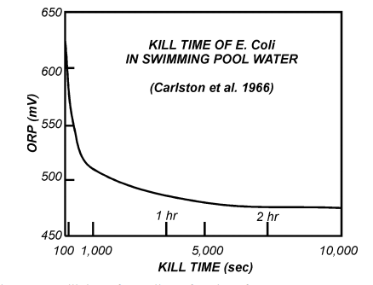
Figure 5: Kill time of E. coli for a typical ORP range (Steininger, 1985)

What can ORP measurement not tell us?

ORP is not a direct substitute for free available chlorine measurement. Free available chlorine can consist of hypochlorite ions, which hold a negative charge (like many micro-organisms but unlike hypochlorous acid), and can actually decrease ORP readings – despite still having a degree of disinfection power. This issue will occur at higher pH values, and can be seen in Figure 6.
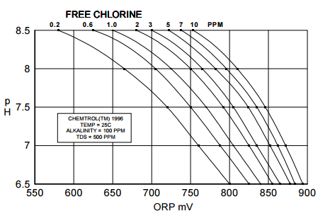
Figure 6: Free chlorine vs ORP, for a range of pH values (Steininger, 1998)

Reiterating that ORP is the measurement the tendency of a sample to either donate or accept electrons, ORP could be high despite low concentrations of hypochlorous acid, if the balance between the oxidising and reducing agents in the water is off or other oxidants are present. Therefore, a high ORP reading cannot guarantee that a disinfection buffer will be available for water flowing into reticulation.

Similarly, ORP could be low at high concentrations of hypochlorous acid, if the water is highly contaminated. This is more of an issue for sewage treatment plants.

3.0 CONCLUSION

FAC and ORP are commonly measured in the water industry, and the results of these measurements can reveal useful information about the disinfection power of disinfectants in a sample of water. There are limitations to relying on one measurement over the other, and ideally both should be used to gain a full understanding of the disinfection power in water.

Sometimes FAC and ORP measurements require additional information to qualify the disinfection power in water, such as the pH of the water, total available chlorine concentration, or ammonia concentration.

4.0 REFERENCES

Hach (2017). Hach Disinfection Series: Chlorine Chemistry. Web: <https://www.hach.com/DisinfectionSeries02>.

Queensland Health (2004). Swimming and Spa Pool Water Quality and Operational Guidelines. Queensland Health.

Samer, M. (2015). Wastewater Treatment Engineering, 1st Ed. InTech, Rijeka.

Steininger (1985). PPM or ORP: Which Should Be Used? Swimming Pool Age & Spa Merchanidiser, November 1985.

Steininger (1998). ORP Control in Pools and Spas. Santa Barbara Control Systems, Santa Barbara.

World Health Organisation (1971). International Standards for Drinking-Water, 3rd Ed. World Health Organisation, Geneva.

