ASSESSING THE ACCURACY OF LABORATORY RESULTS

Dr Travis Robinson, Senior Trainer, Simmonds & Bristow

ABSTRACT

Many water industry operators undertake their sampling, send off their samples to the lab, and trust that the results that they get back are accurate. However, there are times that the results that the lab provides are not an accurate depiction of the quality of the sampled water or wastewater product.

This presentation provides you with a quick overview of some tools that you can use to check the accuracy of the results from your lab. It gives an indication of how your nitrogen results should balance, how to compare your total analytical results to the dissolved or other fractions, an overview of how organic components should balance in wastewaters, as well as quality control sampling options.

Developing skills in the interpretation of lab results will enable you to more easily determine if a threshold exceedance detected in your sampling regime has actually occurred, or if your lab results are likely to blame, which could save you a large amount of time and money so you don’t have to unnecessarily investigate and rectify a fault that never occurred.

1.0 INTRODUCTION

Water industry operators are required to undertake a number of sampling and analytical tasks as part of their job requirements. Although some anaysis is undertaken in the field, most of the time water samples are taken and then submitted to an external lab for analysis.

Although some labs are able to deliver relatively accurate results on most occasions, and have their own internal Quality Assurance programs designed to ensure that the results that they provide are accurate, there are situations where results are issued to water industry operators that contain errors.

These mistakes are often caused by human error, and may be brought about by failures in laboratory processes, or from transcription errors. At other times, they may be the result of intrumental error.

The purpose of this paper is to provide water industry operators with some tools that enable them to check the accuracy of their laboratry results when they are received. Knowledge of these tools has enabled Simmonds & Bristow on a number of occasions to recognise when erroneous sampling results have been provided by external laboratories, and to avoid our clients from instigating expensive and needless investigations into the performance of their plant or the impact of their activity when it is not warranted.

2.0 DISCUSSION

2.1 Knowldege of Typical Results

One of the best ways to assess whether your sampling results are unsual is to compare your current results to those previously collected to detemine if there are any trends or variations. An example set of results that displays the variation in concentrations is found in Figure 1.
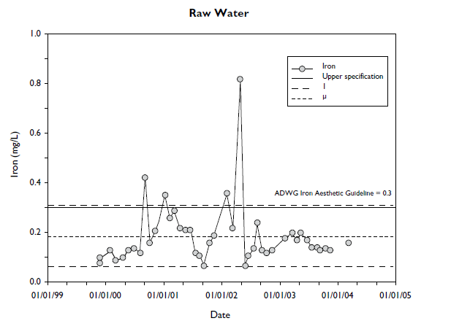
Figure 1: Typical trend graph showing historical trends (source: ADWG)

If laboratory results are substantially different compared to historical trends, then it is a good opportunity for water industry operators to explore if this variation is due to a change in the sampled water, or is due to a laboratory result.

Another method to compare water quality results is to compare them to some form of typical or background concentration. Depending on the source of the sample, guidance for typical concentrations for a number of test parameters can be found for drinking water (e.g. Australian Drinking Water Guidelines or ADWG), wastewater treatment systems (e.g. the Australian Recycled Water Guidelines or ARWG), or for general water quality of waterways (e.g. ANZECC Water Quality Guidelines).

Some examples of typical water quality results for watercourses and recycled water, and for maximum cocnentrations in drinking water, are provided in Table 1.

Table 1: Typical concentrations of various water sample sources

Parameter | Units | Drinking Water | Recycled wastewater | Watercourse
Nitrate | mg/L NO₂N | 11 | 2.3 | 0.04
Ammonia | mg/L NH₄-N | 0.4 | 6.9 | 0.02
pH | pH units | 6.5-8.5 | 6.2-9.8 | 6.5-8.0
EC | µS/cm | 800 | 1,300 | 125-2,200
Turbidity | NTU | 5 | 5 | 6-50
Chlorine | mg/L | 5 | 0.5 | -
Zinc | mg/L | 3 | 0.05 | 0.008
Source: Drinking Water: ADWG 2011 (maximum),: Recycled Water: ARWG 2006; Watercourse ANZECC WQG 2000

2.2 Total vs Dissolved Fractions

Another method to check the accuracy of laboratory supplied results is to compare the different fractions of heavy metals and other inorganic compounds.

Any total concentration includes the total amount of each parameter present in the sample. The analysis of total concentrations includes an acid digestion, so any fraction of a parameter that is present within the sample will be included in the total concentration.

By contrast to this, the dissolved fraction only includes any readibly soluble fraction of the parameter, so any fraction of the parameter within the sample that is not soluble (e.g. precipitated fractions, fractions bound to organic matter or iron or manganese, etc.) will not be included in this fraction.

Taking this into consideration, one way to check your results is to therefore compare the total and dissolved fractions of your results, and ensure that the total fraction is greater in magnitude than the dissolved fraction.

When comparing these two fractions, it is also a good idea to also take into consideration the pH of the sample. pH has a large impact on the availability of the element within the sample (i.e. dissolved fraction), with elements such as copper, zinc, and cadmium often having higher soluble concentations in acidic pH conditions compared to in alkaline conditions.

2.3 Compounds compared to element concentration

Another method to compare results is to examine the concentration of compounds compared to the concentration of the elements within that compound.

One example is to compare the concentration of sulphate to the total sulphur concentration. One set of results we recently received from a laboratory had a total sulphur concentration of 310 mg/L, and a sulphate (as sulfur) concentration of <0.3 mg/L. However, an examination of previous results for the site indicated that the sulphur concentration was predominantly comprised of sulphates. The laboratory were contacted and asked to check the results, and it was found that the sulphate concentration had been transcribed incorrectly and should have been 929 mg/L.

A quick check was then undertaken to ensure that this result was correct, with an overview of this results check provided below:

Sulfate as a fraction of total Sulfur:
Sulphate = SO₄
Sulphur MW = 32; Oxygen MW = 16
Sulphur component of SO₄ = [32/(32+(16*4))]*929
=310 mg/L (which is equivelent to the total sulphur concentration).

2.4 Organic compounds

A means of checking the accuracy of laboratory organic results is to ensure that the total petroleum hydrocarbon concentration (TPH) is less than the total recoverable hyddrocabon (TRH) results.

The analysis of TPH and TRH is similar, in that it is an analysis of the hydrocarbons within a sample, however the TPH method includes the removal of polar compounds that are not associated with man-made petroleum products by the use of silica-gel.

Therefore, the TRH analysis will also include extractable petroleum compounds (polar compounds) such as:

- Phthalates, pesticides, natural oils, PCBs, AFFFs;
- Organic acids from leaves (gum leaves, sap);
- Peat lenses;
- Shale (can also include PAHs/dioxins);
- Grease trap waste or biosolids;
- Vegetable/animal oil (grease);
- Compost;
- Highly fertile soil (humic/fulvic acid)

Although the comparison of the TPH and TRH is a good method to check the results of your sample hydrocarbon analysis, it is also important to ensure that you are testing for the correct parameter as required by your sampling organisational procedure or licence.

2.5 Nitrogen compounds

Another issue commonly encountered in incorrect laboratory results is the nitrogen compounds not balancing with the total nitrogen concentration.

The relationship betweent the different components of the nitrogen balance are highlighted in Figure 2 below.
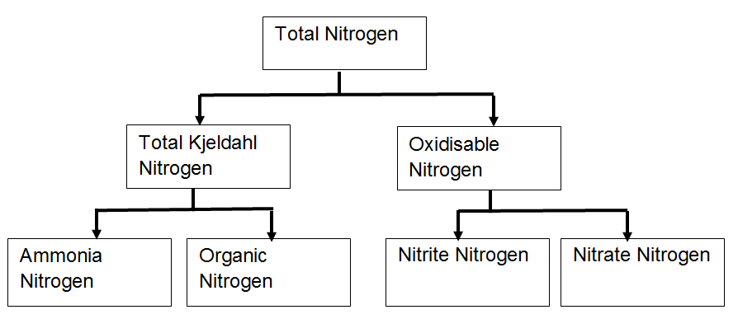
Figure 2: Nitrogen balance of laboratory results

Taking into consideration the nitrogen balance, we can therefore make the following assumptions with regards to our nitrogen results:

- Total nitrogen results should be greater than all other fractions (i.e. ammonia-N should be less than total-N);
- Total nitrogen should equal total kjeldhal nitrogen plus oxidisable nitrogen;
- Total kjeldahl nitrogen results should equal the ammonia nitrogen results plus the organic nitrogen results;
- Oxidisable nitrogen results should equal the sum of the nitrate-N and nitrite-N results.

It is also important to remember that you are comparing the correct units when undertaking this comparison (i.e. using nitrate-N results in the comparison as opposed to the nitrate results).

Any occasion where the nitrogen results do not balance (apart from small differences associated with method accuracy) should result in the laboratory results being checked to assess the cause of the error

2.6 QA/QC sampling

Another method to assess the accuracy of laboratory results is to undertake Quality Assurance/Quality Control (QA/QC) sampling.

Examples of quality control samples include:

- The use of reference sites for comparison;
- Control samples;
- Field spikes;
- Field, transport and container blanks.

A blank is a portion of deionised water that is carried through all or part of the sampling and analytical process and is designed to provide an indication of contamination. It is important that the volume used for blanks be the same as the samples. Conversely, spiked samples contain a known concentration of an element that can be tested when the samples are returned to the laboratory.

Duplicate or triplicate samples are taken to test for analytical precision in the laboratory and put through the same filtering, storage and analysis processes.

One sample is split, or three samples bottled in immediate succession and each is given its own identification number.

Duplicate or triplicate samples can be used to monitor the reproducibility of sampling and laboratory analysis.

2.3 Other methods to check results

The accuracy of the laboratory analysis can also be readily checked by looking at the anion-cation balance. Since water is neutrally charged, the sum of anions should roughly equal the sum of cations. The anion-cation balance is normally expressed as percentage.

Ion balance = (ΣC - ΣA)/(ΣC + ΣA)/100

Where, ΣC is the sum of cations and ΣA is the sum of anions

If the anion-cation balance is >5%, this may indicate an error in analysis, and the results should not be relied on for subsequent interpretation unti they are investigated.

According to the ADWG, the reliability of monitoring data is also dependent on a number of factors, including:

- Sample integrity (how well the sample is preserved);
- Detection limits (How low an instrument is able to detect);
- Measurement uncertainty (how accurate an instrument is able to detect).

All of these measures should be taken into consideration when reporting sample results. Any results that are out of specification or atypical should be noted on the results document that is issued, and taken into account when interpreting the results.

3.0 CONCLUSION

Despite the quality control processes present in most laboratories, sample results that are analysed at laboratories are not immune to containing errors.

Water industry operators have a number of options open to them to enable them to check the accuracy and reliability of their laboratory data, including monitoring on-going trends, comparing to typical concentrations, ensuring that different components of the results balance, and by undertaking additional QA/QC sampling.

Taking the time to check the accuracy of your laboratoy results prior to making decisions regarding process performance or reporting of non-conformances of sample results is a worthwhile practice that could save you a large amount of time and money so you don’t have to unnecessarily investigate and rectify a fault that never occurred.

4.0 ACKNOWLEDGEMENTS

The author would like to acknowledge the valuable assistance provided by Liz Millan, Bill Oldroyd and Xin Zhang in producing this paper.

5.0 REFERENCES

Australian and New Zealand Environment and Conservation Council and Agriculture and Resource Management Council of Australia and New Zealand (2000), Australian and New Zealand guidelines for fresh and marine water quality. Volume 1, The guidelines, (ANZECC Water Quality Guidelines): http://www.environment.gov.au/system/files/resources/53cda9ea-7ec2-49d4-af29-d1dde09e96ef/files/nwqms-guidelines-4-vol1.pdf

Natural Resource Management Ministerial Council, Environment Protection and Heritage Council and Australian Health Ministers’ Conference (2006), National Guidelines for Water Recycling: Managing Health and Environmental Risks, National Water Quality management Strategy, November 2006 (“The Recycled Water Guidelines”): http://www.environment.gov.au/system/files/resources/044e7a7e-558a-4abf-b985-2e831d8f36d1/files/water-recycling-guidelines-health-environmental-21.pdf

NHMRC, NRMMC (2011), Australian Drinking Water Guidelines Paper 6 National Water Quality Management Strategy, National Health and Medical Research Council, National Resource Management Ministerial Council, Commonwealth of Australia, Canberra (The “ADWG”): https://www.nhmrc.gov.au/_files_nhmrc/file/publications/nhmrc_adwg_6_february_2016.pdf

